1. 聽力測驗 (10%)

第一部分：看圖辨義 試卷上該題有一張圖片，請聽一個和該題相關的問題，與(A)、(B)、(C)三個英語 敘述後，選一個與所看到圖片最相符的答案。

|  |  |
| --- | --- |
| 7-1 | 8-1 |
| 1. ______ | 2. ______ |

第二部分：問答 每題會播出一個問句或直述句，聽後請由試卷上(A)、(B)、(C)三個選項中，選出一個 最適合的回答或回應。

_______ 3. (A) I always have a dictionary with me.   
(B) I don’t really like that proverb.   
(C) I like the tale of *Romeo and Juliet*.

_______ 4. (A) Yes, it happened in 1982.   
(B) Yes, it was a story about a ruler who built a cave.  
(C) Yes, it means you should be careful of what you say.

_______ 5. (A) I can pick the lock with this wire.  
(B) Just use your keys to open it.  
(C) Thanks for letting me inside.

第三部分：簡短對話 每題會播出一段對話及一個相關的問題，聽後請由試卷上(A)、(B)、(C)三個選項中，選出一個最適合的回答。

_______ 6. (A) The man.   
(B) The woman.   
(C) The man’s grandfather.

_______ 7. (A) To become a music teacher.  
(B) To practice more.  
(C) To play the guitar on the street.

_______ 8. (A) Before he went to the magic show.   
(B) At the magic show.   
(C) After he went to the magic show.

第四部分：短文聽解 每題有三個圖片選項。請聽題目，並選出一個最適當的圖片。

9. _______

(A) (B) (C)

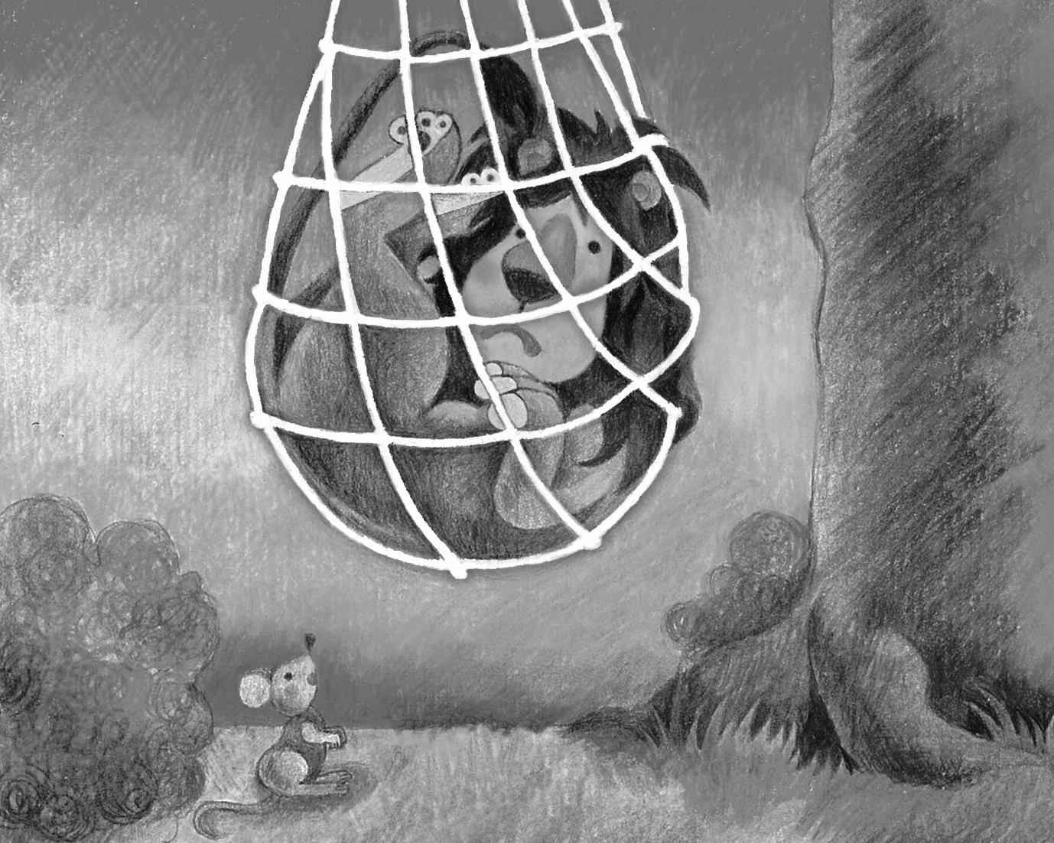 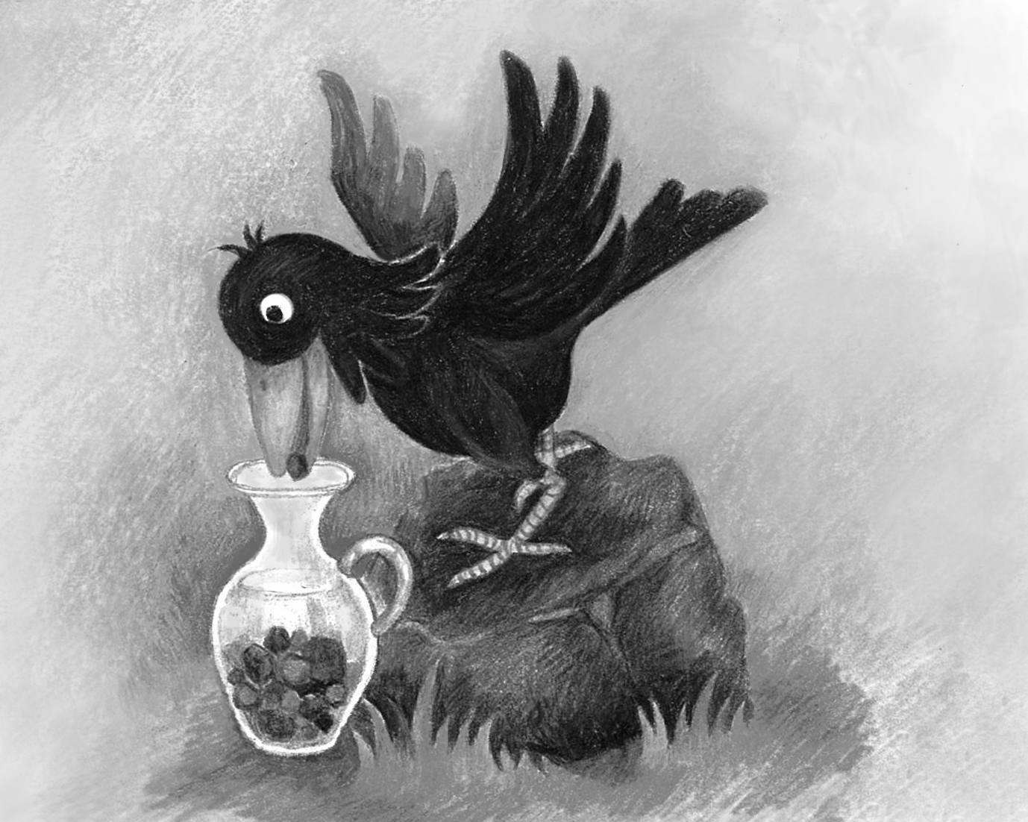 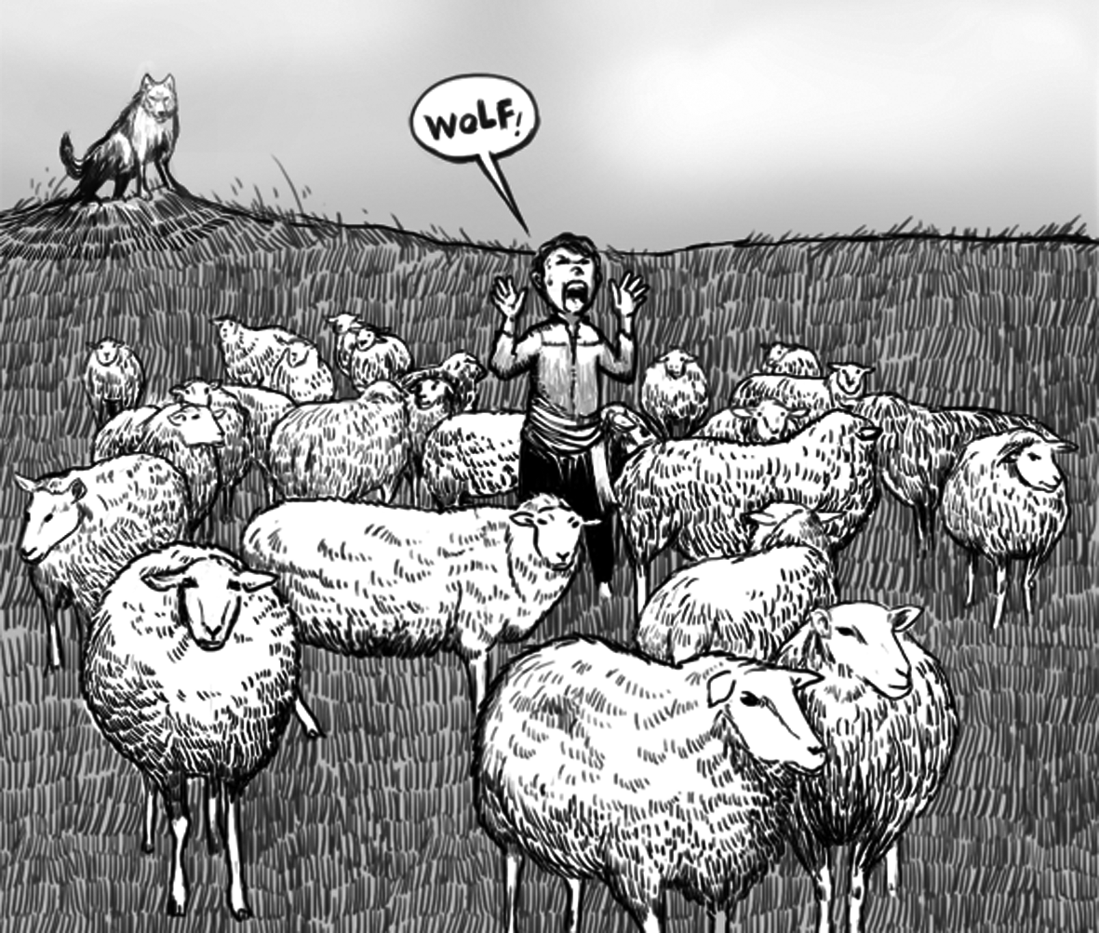

10. _______

(A) (B) (C)

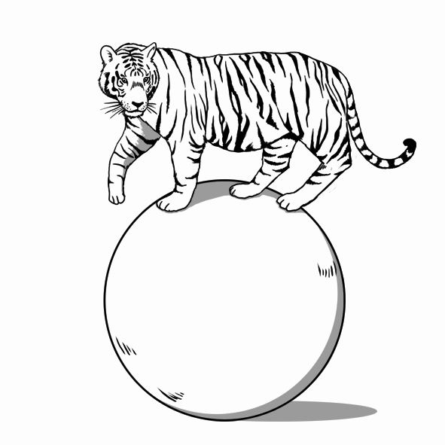 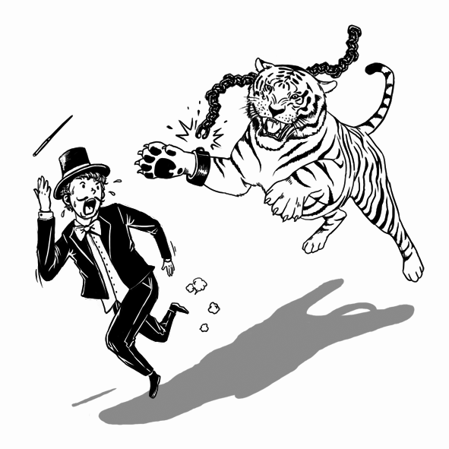 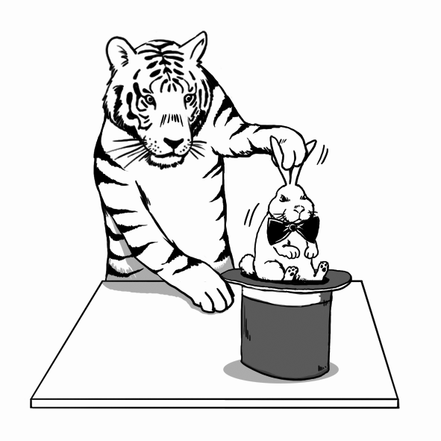

二、文意字彙 (36%)

11.（　　）Some people enjoy the _____ of the countryside, but I find it scary.

(A) silence　(B) convenience　(C) importance　(D) discovery

12.（　　）In 1492, Columbus (哥倫布) _____ America, but he thought the new land was India.

(A) wrapped　(B) discovered　(C) lowered　(D) divided

13.（　　）The NASA said that water was found on the _____ of Mars (火星).

(A) lock　(B) speed　(C) surface　(D) illness

14.（　　）“Walls have ears” is a _____ to remind people to be careful of what you say.

(A) source　(B) proverb　(C) poetry　(D) wisdom

15.（　　）The performance of the street _____ always attracts crowds of people.

(A) tank　(B) tourist　(C) ability　(D) artist

16.（　　）Although the _____ of this story is unknown, it has become very popular in my country.

(A) ancestor　(B) tale　(C) source　(D) illness

17.（　　）Phil was very lucky because he _____ from the big fire.

(A) entered　(B) escaped　(C) excused　(D) explained

18.（　　）The king built a huge _____ to hide his treasures.

(A) prison　(B) myth　(C) period　(D) cave

19.（　　）Advances in medical _____ have saved countless (無數的) lives.

(A) surface　(B) threat　(C) wire　(D) technology

20.（　　）King John had _____ this country for twenty years before he passed away.

(A) leaped　(B) ruled　(C) discovered　(D) explained

21.（　　）The sports car is too expensive for a(n) _____ person to buy.

(A) ordinary　(B) clever　(C) wise　(D) honest

22.（　　）This car has a(n) _____ color. I’ve never seen it anywhere else.

(A) ancient　(B) unique　(C) cunning　(D) various

23.（　　）The English teacher is patiently _____ the difficult grammar rules to her students in the

classroom.　(A) behaving　(B) explaining　(C) discovering　(D) accepting

24.（　　）The Greek government is trying hard to improve the economy in order to _____ the

unemployment (失業) rate.　(A) achieve　(B) escape　(C) develop　(D) lower

25.（　　）The goal of Tomb-Sweeping Day (清明節) is to express our respect to our _____.

(A) rulers　(B) prisoners　(C) poets　(D) ancestors

26.（　　）Each member of the band has outstanding (顯著的) musical skills.

(A) ancestors　(B) illnesses　(C) addresses　(D) abilities

27.（　　）Elephants are smart enough to hide their dying places so that no humans can find them.

(A) public　(B) equal　(C) clever　(D) legal

28.（　　）Eating too much fast food can lead to serious health problems.

(A) result from　(B) result in　(C) belong to　(D) fall for

三、語法與慣用語 (24%)

29.（　　）Be careful of what you post on the Internet because you don’t know _____ might read it.

(A) who　(B) whom　(C) what　(D) that　

30.（　　）The owner of the big house is going to have the kitchen and bedrooms _____.

(A) painted　(B) paint　(C) be painted　(D) to paint

31.（　　）Did you mean _____ I should stay at home tonight?

(A) how　(B) what　(C) that　(D) which

32.（　　）Last Sunday, I talked to Teresa _____ is my new neighbor.

(A) who　(B) , who　(C) which　(D) , which

33.（　　）Which is _____, the cell phone or the digital camera (數位相機)?

(A) the cheapest　(B) more cheap　(C) cheaper　(D) the cheaper

34.（　　）Body language can _____ different meanings in different countries.

(A) use to express　 (B) be used to expressing

(C) be used to express　 (D) use to be expressed

35.（　　）The student didn’t know _____ answer the teacher’s questions.

(A) what to　(B) how to　(C) how should he　(D) what should he

36.（　　）Of all the students, Anna studies _____.

(A) harder　(B) the hardest　(C) hard　(D) hardly

37.（　　）My grandfather is not good at speaking English, so he can’t make himself _____ when he

speaks it.　(A) understand　(B) understanding　(C) understood　(D) to understand

38.（　　）I feel terrible that I _____ that stupid April Fools’ Day trick.

(A) led to　(B) fell for　(C) came down　(D) fell on

39.（　　）_____, scientists and doctors still have not found a cure for AIDS.

(A) To this day　(B) Once upon a time　(C) When it comes to　(D) All of a sudden

40.（　　）On Mother’s Day, Cindy made a strawberry cake _____ a heart for her mom.

(A) in the shape of　(B) in place of　(C) instead of　(D) in spite of

四、綜合選擇 (10%)

Once upon a time, there was a shepherd boy, __41___ watched his sheep at the foot of a mountain. He felt very lonely, ___42__ he thought of a plan for some excitement. He rushed down to the village calling out “Wolf! Wolf!” The villagers came out to help him, __43___ this pleased (讓…開心) the boy. After a few days, he tried the same trick again and the villagers came to help. But one day, a wolf actually came out, and the boy cried out “Wolf, Wolf” even __44___ than before. This time, the villagers thought the boy was cheating them again, so nobody came to help him. Therefore, the wolf had a good meal of sheep, and when the boy complained, one of the villagers said,“A person that lies so often cannot __45___ even sometimes he might tell the truth.”

（　　）41. (A) which　(B) who　(C) whom　(D) that

（　　）42. (A) though　(B) however　(C) so　(D) because

（　　）43. (A) and　 (B) after　 (C) before　(D) but

（　　）44. (A) more loud　(B) loudest　(C) very louder　(D) louder

（　　）45. (A) trust　(B) be trusting　(C) have trusted　(D) be trusted

五、對話(10%)

46.（　　）Victor: What kind of movies do you like?  
 Linda: I like action movies. They’re so exciting.  
 Victor: _____ I prefer comedies, and you know sometimes action movies can be very

bloody.

(A) Great minds think alike.　 (B) Every man has his taste.

(C) Actions speak louder than words.　(D) A friend in need is a friend indeed.

47.（　　）Zack: My art teacher’s paintings are displayed at the Culture Center.   
 Una: Wow, that’s great. _____

(A) I owe you one.　 (B) Let’s go to take a look.

(C) Don’t forget to come again.　(D) I’ve heard a lot about you.

48.（　　）Tracy: Mom, I would like to learn dancing.   
 Mom: Okay, but you still have to pay attention to your studies.  
 Tracy: _____

(A) Here we are.　 (B) Are you kidding?

(C) It’s an awful day.　(D) I know. I’ll try my best.

49.（　　）Dora: It’s amazing that the little boy can play the piano so well.  
 Emily: _____

(A) You can say that again.　(B) I feel bored.

(C) My pleasure.　 (D) You are welcome.

50.（　　）Ben**:** Where do you think we should get married?  
Rachel: I was thinking about Greece.  
 Ben: Perfect! That’s what I was thinking, too!  
 Rache**l:** You know what they say—“_____”

(A) When in Rome, do as the Romans do.　(B) The pen is mightier than the sword.

(C) Better late than never.　 (D) Great minds think alike.

六、閱讀測驗 (10%)

There are so many TV channels now. People have a lot of choices when they turn on their TVs.

Then, how do TV networks compete with one another? To begin with, they need to provide TV

programs that are interesting enough to attract a big viewing audience. Second, they need to find a

suitable time for each program. For example, it is better to play cartoons at 5 p.m. because that is the

time when children come home from school and can take a short break before they do their

homework. Some people call 9 a.m. to 4 p.m. the “housewives’ time.” During this period, soap operas,

romantic movies, and talk shows are usually very popular. Between 6 p.m. and 8 p.m., families may be

watching news which is suitable for **viewers** of all ages. After 11 p.m., when the children have gone to

bed, it is safe to air movies or talk shows that are only suitable for adults. On weekends, some special

programs are offered to attract the people who would rather stay home than go out. So, if you turn on

your TV on a Saturday afternoon, it is probable that you can watch the latest movies, magic shows,

beauty contests, or talent shows. Television networks know the best time to play each kind of program.

As viewers, we are lucky to have so many interesting programs to choose from every time we turn on

the TV.

（　　）51. According to the passage, what is a suitable time to show cartoons?

(A) 5 p.m.　(B) 9 a.m.　(C) 7 a.m.　(D) 7 p.m.

（　　）52. Which of the following statements is NOT true about TV networks?

(A) They have to compete with one another.

(B) They need to provide interesting programs.

(C) They know when is the best time to play each kind of program.

(D) They think that there is no need to suit viewers’ tastes.

（　　）53. Which program is least likely to appear on TV at 2 p.m. on weekdays?

(A) A romantic movie.　(B) A magic show.　(C) A soap opera.　(D) A talk show.

（　　）54. Which of the following is the word “**viewers**” closest to in meaning?

(A) children　(B) audiences　(C) adults　(D) housewives

（　　）55. What time can adults expect to watch programs that are only for them?

(A) 11 a.m.　(B) 6 p.m.　(C) 11 p.m.　(D) 9 p.m.